
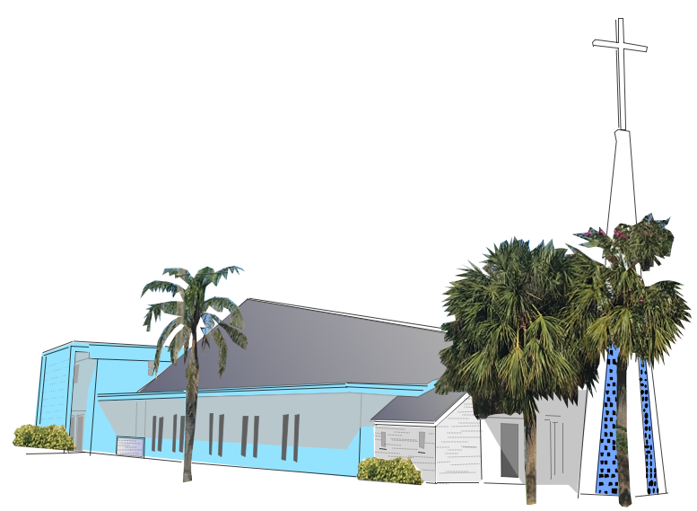
Community Church
4433 Bougainvilla Drive
Lauderdale-By - The Sea, FL 33308

Community Flea Market & Artisan Fair Application
First Saturday of the Month - Time 8:00 am – 2:00 pm
From October 5, 2024 to May 3, 2025
Date or dates you are reserving for: __________________________________________
Vendor Contact Information (Please Print)
Applicant’s Name: ______________________________________________________________
Name of Business: ______________________________________________________________
Cell Phone: _________________________ Home Phone: ________________________________
Fax if Applicable: ________________________________________________________________
Email: _________________________________________________________________________
Sale Item(s) Information:
____________________________________________________________________________________________________________________________________________________________________________________________________
Please Note: Only items listed may be sold. We cannot guarantee exclusivity of items. Misrepresentation of sale items may result in removal from the event.
NO REFUNDS.
Inside Vendors Table information
6-foot table & 2 chairs ______ # of tables at $30.00 per table = $ _________ does not include use of the extra space or counter space located behind a few tables without an additional fee of $10.00 ____
Outside Vendors space information
15-foot-wide space with vehicle ___ # of spaces at $20.00 per space = $ _________ Set up time 7am on Saturday
Make check or money orders payable to: Community Church
Zelle payments to 954-829-1602
Returning Vendors Registration New Vendors Registration
End of the Current event to ensure same location UNTIL SOLD OUT
ALL VENDOR SPACES ARE RESERVED ON FIRST PAY, FIRST SERVED BASIS
Rain or Shine No Refunds Unless the Community Church cancels the event.
Community Church 4433 Bougainvilla Drive Lauderdale-By - The Sea, FL 33308
Community Flea Market & Artisan Fair Application
First Saturday of the Month from October 5, 2024 to May 3, 2025
Date or dates you are reserving for: __________________________________________
Rules and Regulations
This is a one-day event to be held regardless of weather conditions and electricity will not be provided.
Community Church reserves the right to change event dates and hours.
All participating vendors must adhere to the hours of operations for set up, sale and breakdown as follows:
Indoor vendors may set up on Friday from 3pm to 6pm or Saturday from 7 am to 8am.
Outside vendors Saturday morning only 7am to 8am
The sale begins at 8 am. Break down is at 2pm. All vendors off site by 3pm
- Inside Vendors are permitted to unload behind the building by the park, after unloading inside vendors vehicles must be parked in designated parking areas only. Outside vendors vehicles need to part of their space or in the city paid parking.
- As a courtesy to customers and your fellow vendors, you are requested to have your area covered if you are away from your area for any reason.
- All inside vendors will be assigned the requested number of 6 ft tables and two chairs. All items need to fit on top of their tables or on the floor no more than six inches in front of the table. All vendors must vacate the event by 3pm.
- All outside vendors must include their vehicle within the space or utilize the city paid parking areas. The outside sale area begins five feet from the road and is ten feet wide. All vendors must vacate the event by 3pm.
- All vendors are responsible for the cleanup of trash from their area. Unsold items must be removed after the event unless other arrangements have been made prior to the end of the event.
- All vendors are encouraged to provide all items needed to sell their items. This includes bags, wrapping / packing materials and ample money to provide change for sale items. Community Church will not be able to provide change for vendors.
- The Community Church reserves the right to stop and or remove from the event any vendor or vendor representative performing any act or practice, which in their opinion is objectionable or distracts from the purpose/ objective of the event.
- Property brought onto the premises by any vendor is at the sole risk of the vendor and shall be removed from the premises during designated breakdown times. The Community Church shall have the right to remove from the premises any remaining items left after the designated move-out time of 3 pm and may also charge the vendor a cleanup fee.
- The Community Church reserves the right to ask a vendor to remove any objects deemed objectionable for any reason or not listed on the application.
CONTRACT AGREEMENT
I have read the general information regarding vendor registration. It is understood and agreed by the applicant that this entire document constitutes a contract between the vendor and The Community Church. Verbal agreements or promises made verbally and not specifically stated and confirmed in writing, as part of the agreement, will not be binding.
Applicants Signature: ______________________________________ Date: ________________
----------------------------------------------------------- (Office Use Only) - ---------------------------------------------------------------------------
Inside Table Number(s): __________ Number of 6-foot tables: _____________________ does not include use of the counter space or additional without an additional fee of $10.00 ____
Outside vendor Number(s): ______________ Number of 15-foot spaces: _____________________
Paid by: Zelle $ _____Cash $______ Check # ________ Amount $________ Received by: ____________

